Lecture 7.

Infection. Immunity, its types: innate (non-specific) and acquired (specific) immunity. Innate (non-specific), its features and factors

The purpose of the lecture: Introduce students to the concepts of "infection", "infectious process" and "infectious disease". To provide information about the conditions of the infectious process, the role of microorganisms, macroorganisms and environmental factors in the infectious process. Explain the factors of pathogenicity and virulence. To acquaint students with the concept of "immunity", historical information about immunity, the main defense mechanisms and types of immunity, to inform them about non-specific immunity, its factors.

Lecture plan:
1. Infection
- The origin of the term "infection". Explanation of the concepts of "infection", "infectious process", "infectious disease".
- Conditions for the occurrence of the infectious process.
- The role of microorganisms (pathogenic, opportunistic, saprophytic) in the infectious process. The concept of pathogenicity and virulence of microorganisms. Pathogenic factors: adhesion and colonization ability, invasiveness, antiphagocytic factors, toxigenicity. Units of virulence (DLM, DCL, LD50, ID100, ID50). Factors that increase and decrease virulence.
- Microbial toxins. Exotoxins and endotoxins, their properties and classification
- Genetic basis of pathogenicity and virulence.
- The role of macroorganisms and the environment in the process of infection.
- Characteristics and periods of infectious diseases.
- Forms and types of infectious process.
- Manifestations of viral infections (productive, abortive, integrative)
- Forms of infectious diseases.
2. Immunity
- Historical information about immunity.
- Types of immunity (congenital, acquired, active and passive).
- Non-specific and specific protection factors
3. Non-specific (innate) immunity
4. Non-specific resistance factors: mechanical, physicochemical and immunobiological barriers.
5. Cellular factors of innate immunity: phagocytes, natural killers, etc.
- Phagocytosis. Types of phagocytic cells, phases of the phagocytic process.
- The role of phagocytes in diseases and defense reactions. Complete and incomplete phagocytosis. Factors accelerating and weakening phagocytosis.
- Opsonization and its mechanism
- Natural killers
6. Non-specific humoral protective factors - non-specific bactericidal properties of blood: lysozyme, complement (activation pathways), lysines, erythrin, leucine, properdin, C-reactive protein, cytokines (interleukins, interferons, TNFα, etc.)

Innate Host Responses
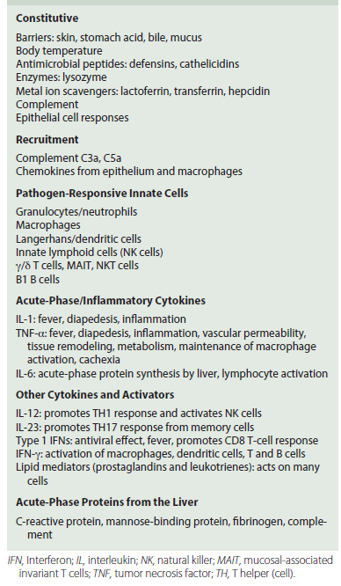

Soluble Innate Defense Mediators
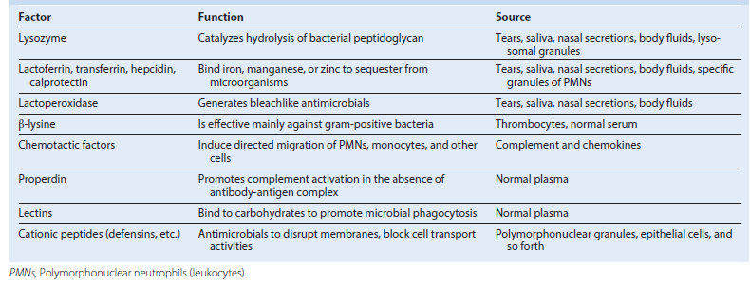

Classical, lectin, and alternate complement pathways. Despite different activators, all three pathways converge toward the cleavage of C3 and C5 to provide chemoattractants and anaphylatoxins (C3a, C5a), an opsonin (C3b) that adheres to membranes, and a B-cell activator (C3d) and to initiate the membrane attack complex (MAC) to kill cells. C9 resembles perforin (natural killer cells and cytotoxic T cells) to promote apoptosis in the target cell. MASP, MBP-associated serine protease; MBP, mannose-binding protein. (Redrawn from Rosenthal, K.S., Tan, M. 2010. Rapid Review Microbiology and Immunology, third ed. Mosby, St Louis, MO.)
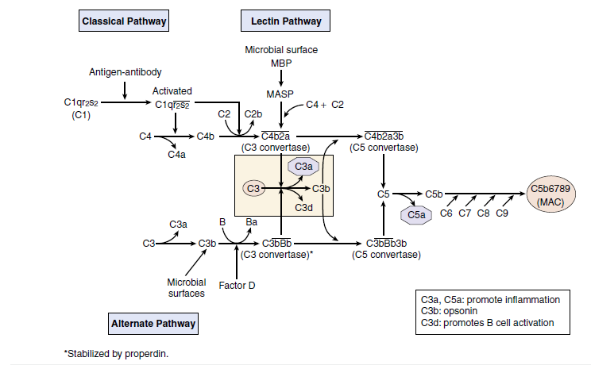

The many functions of macrophages and members of the macrophage family. M2 macrophages maintain the status quo and facilitate wound healing by removal of debris and promoting angiogenesis and tissue repair. M1 macrophages promote antimicrobial killing and inflammation. H2O2, Hydrogen peroxide; IFN-_, interferon-γ; IL, interleukin; NO, nitric oxide; .O−, oxygen radical; .OH, hydroxyl radical; TH, T helper (cell); TNF-_, tumor necrosis factor-α.
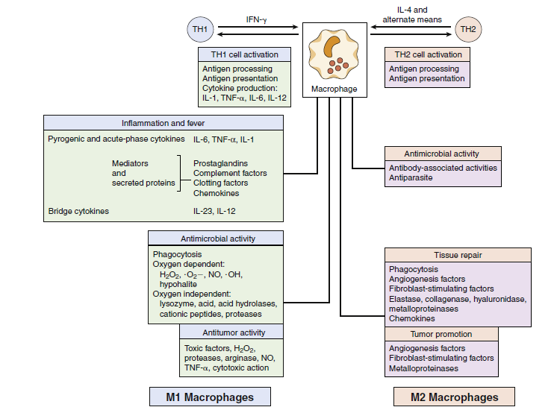

The Many Functions of Macrophages
Status Quo (Peacetime): M2 Macrophages
Phagocytosis and degradation of debris
Production of enzymes and factors for tissue growth and repair
Production of angiogenesis factors
During Infection and Inflammation (At War): M1 Macrophages
(Activated by PAMPs, TNF-_, GM-CSF, and IFN-_)
Phagocytosis and oxygen-dependent and -independent antimicrobials
Acute-phase cytokines: IL-6, TNF-α, and IL-1 (endogenous pyrogens)
Other cytokines: IL-12, GM-CSF, G-CSF, M-CSF, IFN-α
Arachidonic acid metabolites
Prostaglandin, thromboxane, leukotrienes
Enzymes, complement components, coagulation factors
G-CSF, Granulocyte colony-stimulating factor; GM-CSF, granulocytemacrophage colony-stimulating factor; IFN- interferon-α; IL, interleukin;
M-CSF, macrophage colony-stimulating factor; PAMP, pathogenassociated molecular pattern; TNF- tumor necrosis factor-α.

Dendritic Cells
Myeloid and Plasmacytoid (for T cells)
Morphology: octopus-like with tendrils
Activities
Immature DCs
In blood and tissue
Danger sensors, phagocytosis, cytokine production, antigen
processing
Mature DCs
T-cell areas of lymph node and spleen
Only cell that can initiate a new T-cell response
Process antigenic proteins into peptides
Increased expression of molecules for antigen presentation
MHC I-peptide: CD8 T cells
CD1-glycolipids: CD8 T cells
MHC II-peptide: CD4 T cells
B7-1 and B7-2 and other coreceptors
Produce cytokines to initiate and direct T-cell response
Follicular DCs (for B cells)
In B-cell areas of lymphoid tissues
Express sticky receptors to display antigen to B cells (Fc and CR1,
CR2, and CR3 complement receptors, lack MHC II)
CD, Cluster differentiation; DC, dendritic cell; MHC, major histocompatibility complex

Ligands Recognized by Innate T cells
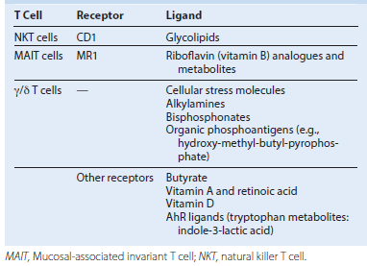

Recognition of pathogen-associated molecular patterns (PAMPs). Microbial structures, RNA, and DNA bind to specific PAMP receptors on the cell surface, in vesicles, or in the cytoplasm to activate innate responses. GP, Glycoproteins; GPI, phosphatidylinositol glycan–anchored proteins; LP, lipoproteins; LPS, lipopolysaccharide; LTA, lipoteichoic acid; MDA5, melanoma differentiation–associated gene 5; NALP3, Nacht, leucine-rich repeat, and pyrin domain–containing protein 3; NOD2, nucleotide-binding oligomerization domain protein 2; PG, peptidoglycan; RIG-1, retinoic acid–inducible gene-1; TLR9, Toll-like receptor 9. (Modified from Mogensen, T.H. 2009. Pathogen recognition and inflammatory signaling in innate immune defenses. Clin. Microbiol. Rev. 22, 240–273.)
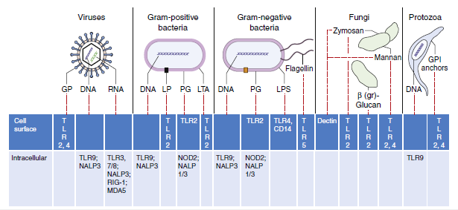

Pathogen Pattern Receptors
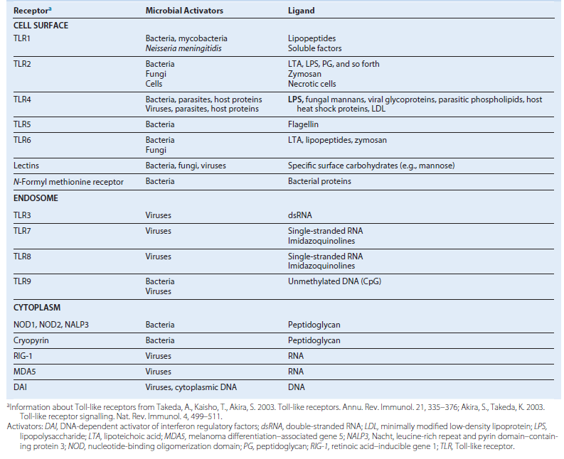

Induction of inflammatory responses. Receptors for pathogen-associated molecular patterns and damage-associated molecular pattern receptors at the cell surface, in vesicles, and in the cytoplasm (1) activate signal cascades that (2) produce adaptor proteins that (3) activate local inflammatory responses. The adaptor proteins trigger the transcription of cytokines and initiate the assembly of the inflammasome. Cytokines activate innate and promote antigen-specific responses. The assembled inflammasome is a protease that cleaves and activates IL-1 and pro–IL-18 and these cytokines promote inflammation. Asbestos and other materials also activate the inflammasome after lysing lysosomes and releasing proteases that cleave precursors to initiate its assembly and activation. ATP, Adenosine triphosphate; FL, flagellin; HSP, heat shock protein; IL, interleukin; LPS, lipopolysaccharide; LTA, lipoteichoic acid; NOD, nucleotide-binding oligomerization domain protein; RIG-1, retinoic acid–inducible gene 1; ROS, reactive oxygen species; TLR, Toll-like receptor; TNF-_, tumor necrosis factor-α.
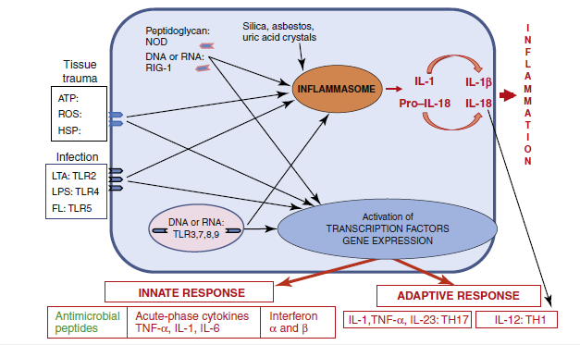

(A and B) Neutrophil diapedesis in response to inflammatory signals. Tumor necrosis factor (TNF)-α and chemokines activate the expression of selectins and intercellular adhesion molecules on the endothelium near the inflammation and their ligands on the neutrophil: integrins, L-selectin, and leukocyte function–associated antigen-1 (LFA-1). The neutrophil binds progressively tighter to the endothelium until it finds its way through the endothelium. Epithelial cells, Langerhans cells, and macrophages activated by microbes and interferon (IFN)-γ make TNF-α and other cytokines and chemokines to enhance diapedesis. IL, Interleukin; NK, natural killer. (A, From Abbas, A.K., Lichtman, A.H. 2012. Basic Immunology: Functions and Disorders of the Immune System, fourth ed. WB Saunders, Philadelphia, PA.)
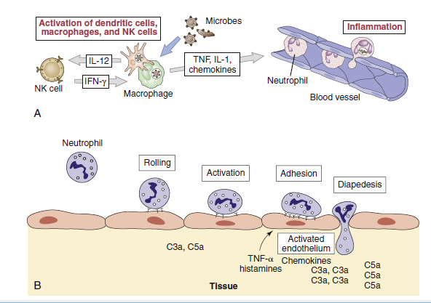

Antibacterial Compounds of the Phagolysosome
Oxygen-Dependent Compounds
Hydrogen peroxide, superoxide, hydroxyl radicals (⋅OH−):
NADPH oxidase and NADH oxidase
Activated halides (Cl−, I−, Br−): myeloperoxidase (neutrophil)
Nitric oxide: nitric oxide synthase
Oxygen-Independent Compounds
Acids
Lysozyme (degrades bacterial peptidoglycan)
Lactoferrin (chelates iron)
Defensins and other cationic proteins (damage membranes)
Proteases: Elastase, cathepsin G, and so forth
NADH, Nicotinamide adenine dinucleotide reduced; NADPH, nicotinamide adenine dinucleotide phosphate reduced.

Phagocytosis and killing of bacteria. Bacteria are bound directly or are opsonized by mannose-binding protein, immunoglobulin (Ig)G, and/or C3b receptors, promoting their adherence and uptake by phagocytes. Within the phagosome, oxygen-dependent and oxygen independent mechanisms kill and degrade the bacteria. NADPH, Nicotinamide adenine dinucleotide phosphate reduced.
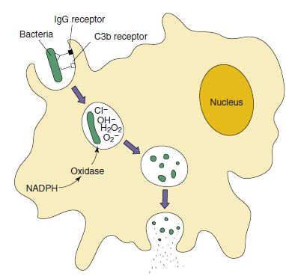

Good, bad, and ugly effects of tumor necrosis factor (TNF)-α and interleukin (IL)-1. Low concentrations activate local inflammation (promote movement of fluid, proteins, and cells from the blood to the site of infection) and supportive responses. High concentrations activate systemic inflammation and shock.
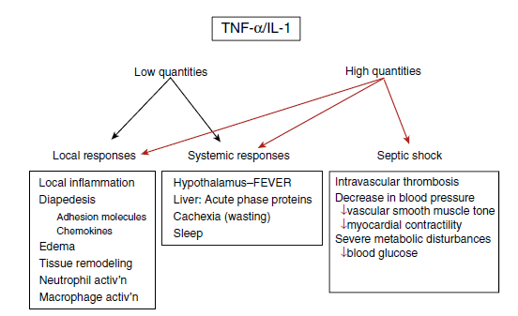

Cytokines of Innate Immunity (STAT)a,b
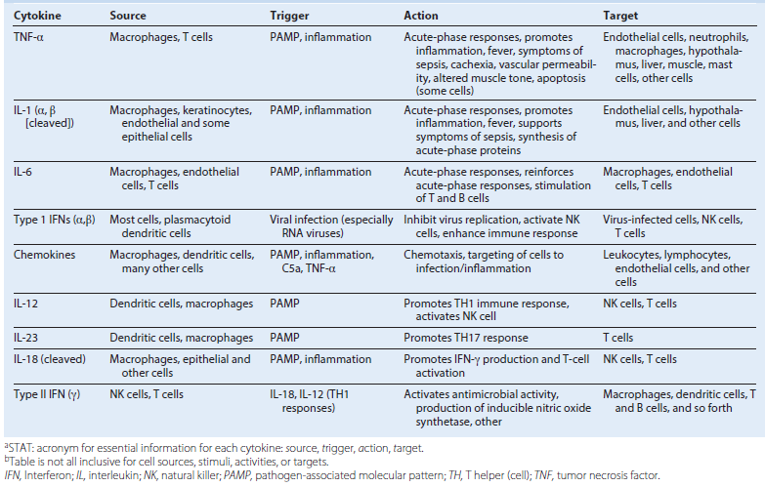

Inflammatory Diseases of the Skin
Acne, atopic dermatitis, and eczema are initiated and maintained by innate keratinocyte and epithelial cell responses after entry of normal flora of the skin surface. Acne is the result of responses to Propionibacterium acnes, whereas staphylococci can drive atopic dermatitis and eczema. P. acnes grows in the anaerobic environment of the hair follicles and can promote keratinocyte growth and sebum production. It also activates TLR2 and TLR4 to initiate inflammatory cytokine (IL-1, IL-6, TNF-α) and chemokine responses from keratinocytes and Langerhans cells to recruit neutrophils and produce squalene, which is a lipid that is often used in vaccine adjuvants that increases IL-1α levels and activates the 5-lipoxygenase enzyme to produce LTB4. P. acnes also activate local ILCs and T cells to promote inflammation. These and other actions can stimulate whitehead and blackhead production, inflammation, and scarring. Atopic dermatitis can result when the epidermal barrier function of the skin is continuously compromised to allow penetration of Staphylococcus aureus or other skin flora into the epidermis and dermis in which keratinocytes respond with IL-1, IL-8, IL-18, and chemokines; mast cells get activated and produce histamine; and macrophages are activated to trigger inflammation. Later, antigen-specific CD4 Th2 cells establish residence in the dermis, produce IL-4, and activate mast cells and inflammation. During the chronic phase of disease, CD4 Th17 and Th1 cells will arrive and activate neutrophils and macrophages, respectively, to exacerbate the inflammation.
CD, Cluster differentiation; IL, interleukin; ILC, innate lymphoid cell; LTB4, leukotriene B4; TLR, Toll-like receptor; TNF, tumor necrosis factor.

Acute-Phase Proteins
α1-Antitrypsin
α1-Glycoprotein
Amyloids A and P
Antithrombin III
C-reactive protein
C1 esterase inhibitor
Complement C2, C3, C4, C5, C9
Ceruloplasmin
Fibrinogen
Haptoglobin
Orosomucoid
Plasminogen
Transferrin
Lipopolysaccharide-binding protein
Mannose-binding protein

Gram-positive and gram-negative bacteria induce sepsis by shared and separate pathways. Lipopolysaccharides (LPSs) activate complement, producing C5a, which promotes inflammation and activates coagulation. LPS, lipoteichoic acid (LTA), and other pathogenassociated molecular patterns (PAMPs) interact with Toll-like receptors (TLRs) and other PAMP receptors to activate inflammation and proinflammatory cytokine production. These can add up to cause sepsis. The thickness of the arrow indicates the strength of the response. Red is for gram-negative bacteria and blue is for gram-positive bacteria. DIC, Disseminated intravascular coagulation; IL, interleukin; SIRS, systemic inflammatory response syndrome; TNF-_, tumor necrosis factor-α. (Modified from Rittirsch, D., Flierl, M.A., Ward, P.A. 2008. Harmful molecular mechanisms in sepsis. Nat. Rev. Immunol. 8, 776–787.)
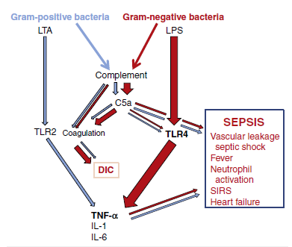

Dendritic cells (DCs) initiate and direct immune responses. Immature DCs constantly internalize and process proteins, debris, and microbes. Binding of microbial components to Toll-like receptors (TLRs) activates the maturation of the DC so that it ceases to internalize any new material; moves to the lymph node and upregulates major histocompatibility complex (MHC) II for antigen presentation; coreceptors B7 and B7-1 and cytokines to activate T cells. The cell-surface interactions and cytokines activate the T cells and direct the nature of the subsequent response. IFN, Interferon; LPS, lipopolysaccharide.
